EXPERIMENT – 12
AIM :
To develop Python programs using Matplotlib to visualize monthly temperature data using a line plot and monthly rainfall data using a scatter plot.

ALGORITHM :
- Import Matplotlib library.
- Store months and corresponding temperature/rainfall values in lists.
- Use plt.plot() to create a line plot for temperature.
- Use plt.scatter() to create a scatter plot for rainfall.
- Label axes and provide titles.
- Display the plots using plt.show().

CODE :
1. CODE – LINE PLOT (Temperature)
import matplotlib.pyplot as plt
months = ["Jan","Feb","Mar","Apr","May","Jun","Jul","Aug","Sep","Oct","Nov","Dec"]
temperature = [22, 24, 28, 32, 35, 34, 33, 32, 30, 28, 25, 23]
plt.plot(months, temperature, marker='o')
plt.xlabel("Months")
plt.ylabel("Temperature (°C)")
plt.title("Monthly Temperature - Line Plot")
plt.grid(True)
plt.show()
2. CODE – SCATTER PLOT (Rainfall)
import matplotlib.pyplot as plt

months = ["Jan","Feb","Mar","Apr","May","Jun","Jul","Aug","Sep","Oct","Nov","Dec"]
rainfall = [80, 60, 50, 40, 30, 20, 10, 15, 25, 50, 70, 90]

plt.scatter(months, rainfall)
plt.xlabel("Months")
plt.ylabel("Rainfall (mm)")
plt.title("Monthly Rainfall - Scatter Plot")
plt.show()

INPUT :
months = ["Jan","Feb","Mar","Apr","May","Jun","Jul","Aug","Sep","Oct","Nov","Dec"]
temperature = [22, 24, 28, 32, 35, 34, 33, 32, 30, 28, 25, 23]
rainfall = [80, 60, 50, 40, 30, 20, 10, 15, 25, 50, 70, 90]

OUTPUT :
1. CODE – LINE PLOT (Temperature)
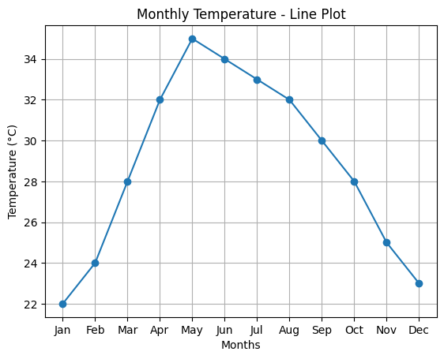

2. CODE – SCATTER PLOT (Rainfall)

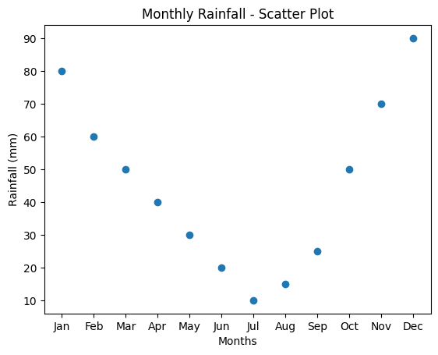

RESULT :
The program successfully visualized the monthly temperature data using a line plot and the monthly rainfall data using a scatter plot.

